 | The Prehistoric Society-SUERC Radiocarbon Award | 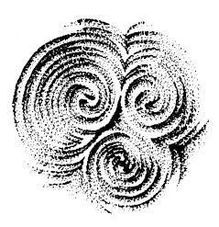

Through the generosity of SUERC, The Prehistoric Society is able to offer an annual award of up to three radiocarbon dates relevant to any field of Prehistory. The applicant(s) must NOT come from a commercial environment nor should the project be financed by one of the national agencies. Applications will be treated on merit and considered with the other Prehistoric Society grant applications (see website for the annual award timetable).

A completed SUERC sample submission form for each sample must be submitted with each application.
Available at:
http://www.gla.ac.uk/research/az/suerc/researchthemes/radiometricsenvironmentalchemistry/radiocarbondating/samplesubmission/

APPLICATION FORM
 |  |  | The Prehistoric Society-SUERC Radiocarbon Award
Name & Address of applicant:

Institution/Group represented:

Site Name or Project:

Email Address (preferred method of contact): |  |  |  |  | Phone:
No of Dates Requested (Max 3): |  |  | List the Funding Source(s) for this Project:
Project Summary (Max 250 words):

Description of sample locations:

Illustrations showing location of samples:

Can the site be dated by other means (associated material, dendrochronology etc)?

Sample | Material to be Dated | Justification for the Date. (Detail stratigraphical integrity, how the death of the sample relates to the event to be dated, associated material etc.)
1
2
3
Declaration:
I declare that the above information is correct and accurate and that no other funding streams are available for these samples.

Signed…………………………………………Date………………………………..

